Interrater Agreement
by Andri Signorell
Helsana Versicherungen AG, Health Sciences, Zurich
HWZ University of Applied Sciences in Business Administration, Zurich
andri@signorell.net

December, 1th, 2025

In many research and applied settings, several raters evaluate the same subjects. To assess the reliability of these ratings, different indices and tests of interrater agreement and reliability are available.

DescTools provides a comprehensive set of functions for this task, including CohenKappa, ICC, Krippendorf’s Alpha, Lin’s Concordance Coefficient and many more.

They work either on rater matrices (containing the raw ratings per subject and rater) or on coincidence matrices (containing the frequency of agreement/disagreement across raters). Functions to convert the long data form into a rater frame are included.

1 Data Structures 2
2 Interrater Agreement Statistics 3
2.1 Overview 3
3 References 4

Note: For all the examples in this document, library(DescTools) must be declared.

Data Structures
Data in the context of interrater agreement analysis comes in different structures. Normally it will be given in one of the following three formats
.
Let us take an example of 3 raters, giving ratings on a scale from 1-6 to 7 subjects.

Wide Long

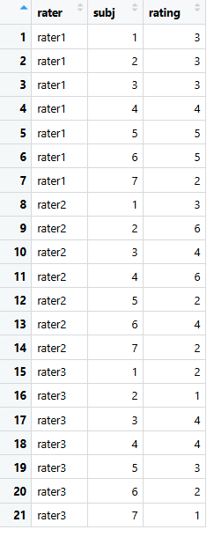
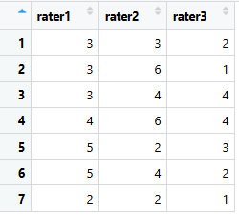

The wide format (Fig. 1) containing the ratings of every rater in an own column and using the rows for subjects is an intuitive, simple and obvious way of organising data when ratings are entered manually into a table. Let us call this a “raterframe”.
The long format (Fig. 2), however, is technically more convenient and flexible for electronic data processing. It is typically used when data are organised in a database.

For further processing it’s convenient to have a standardized interface to the relevant statistics functions.
The function RaterFrame() generates the wide format from a long format using R’s convenient formula notation:

rating ~ subj | rater

d.anx <- data.frame(
rater = c("rater1", "rater1", "rater1", "rater1", "rater1", "rater1", "rater1",
"rater2", "rater2", "rater2", "rater2", "rater2", "rater2", "rater2",
"rater3", "rater3", "rater3", "rater3", "rater3", "rater3", "rater3"),
rating = c(3, 3, 3, 4, 5, 5, 2,
3, 6, 4, 6, 2, 4, 2,
2, 1, 4, 4, 3, 2, 1),
subj = c(1, 2, 3, 4, 5, 6, 7,
1, 2, 3, 4, 5, 6, 7,
1, 2, 3, 4, 5, 6, 7)
)

head(d.anx)
## rater rating subj
## 1 rater1 3 1
## 2 rater1 3 2
## 3 rater1 3 3
## 4 rater1 4 4
## 5 rater1 5 5
## 6 rater1 5 6

rmat <- RaterFrame(rating ~ subj | rater, data = d.anx)
RaterFrame
rmat
## subj rater1 rater2 rater3
## 1 1 3 3 2
## 2 2 3 6 1
## 3 3 3 4 4
## 4 4 4 6 4
## 5 5 5 2 3
## 6 6 5 4 2
## 7 7 2 2 1

The interrater agreement functions in DescTools use a raterframe as basic interface. Make sure to pass only the actual rater columns, and in particular omit the subjects column from the above result.

For the comparison of two raters, it is often convenient to directly use the coincidence matrix form, in which the frequencies of the rating pairs are represented in a symmetric matrix. Such a matrix shows how often each combination of ratings occurs. The rows represent the categories used by the first rater, the columns those of the second rater, and each cell contains the frequency of that rating pair.
In our example we notice that both raters have rated one subject with 2.

rater2
rater1 2 3 4 6
2 1 0 0 0
3 0 1 1 1
4 0 0 0 1
5 1 0 1 0

For more than two raters, this is not a meaningful option.

DescTools contain a function IsCoincidenceTable() which tests, if a matrix or a table fulfils the requirements of a coincidence table. These are:
- square m x m matrix or table
- if there are rownames and columnnames they must be the exactly the same
- contains only nonnegative integer values

NormalizeToCoincidence() normalises data to a coincidence table. This interface is used in the statistics for 2 raters.

Interrater Agreement Statistics

Overview
- 🔎 Overview: Interrater Agreement Statistics
- 1. Key Dimensions that Determine the Choice
- Number of raters:
  - 2 raters
  - More than 2 raters
- Scale type:
  - Nominal (categories without order)
  - Ordinal (categories with natural order)
  - Interval/Metric (continuous or quasi-continuous values, e.g., scores)
- Special contexts:
  - Symmetric vs. asymmetric rater roles (e.g., expert vs. test rater)
  - Complete vs. incomplete data (not every subject rated by every rater)
  - Whether distances between ratings should be weighted

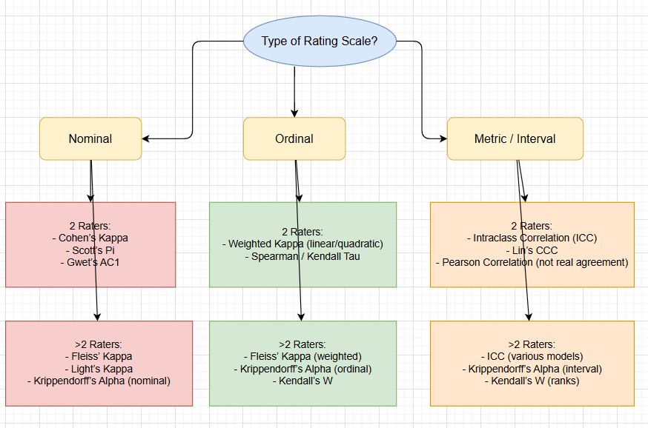

- 2. Overview by Scale Type and Number of Raters
Scale type | 2 Raters | >2 Raters | Notes
Nominal | - Cohen’s Kappa  - Scott’s Pi  - Gwet’s AC1 (more robust to prevalence bias), PABAK | - Fleiss’ Kappa  - Light’s Kappa (mean of pairwise kappas), Randolph’s Kappa  - Krippendorff’s Alpha (nominal) | Kappa depends heavily on marginal distributions; Gwet’s AC1 is often more stable.
Ordinal | - Weighted Cohen’s Kappa (linear/quadratic weights), Gwet’s AC2  - Spearman / Kendall Tau (rank correlation, not strict “agreement”) | - Weighted Fleiss’ Kappa, Gwet’s AC2  - Krippendorff’s Alpha (ordinal)  - Kendall’s W (Coefficient of Concordance) | Weights are important if the size of disagreement matters (e.g., 1 vs 2 vs 1 vs 6).
Interval / Metric | - Intraclass Correlation Coefficient (ICC)  - Lin’s Concordance Correlation Coefficient (CCC) (for 2 raters)  - Pearson correlation (only correlation, not agreement) | - ICC (various models: one-way, two-way, mixed; consistency vs. absolute agreement)  - Krippendorff’s Alpha (interval)  - Kendall’s W (if focus is on ranks) | ICC is the gold standard for continuous data. Krippendorff’s Alpha is flexible and handles missing data.
Binary / Count data | - Kappa (yes/no)  - Phi coefficient / Matthews correlation coefficient | - Fleiss’ Kappa (binary) | Technically a special case of nominal scales.

- 3. Additional Factors
- Symmetry of rater roles:
  - If one rater is a reference standard (gold standard vs. test rater): use sensitivity, specificity, Youden’s Index, ROC analysis, Bland–Altman plots rather than Kappa.
  - For equal raters: use Kappa, ICC, Krippendorff’s Alpha.
- Missing data:
  - Krippendorff’s Alpha is most flexible → works with incomplete data.
  - Kappa and ICC typically require a complete dataset.
- Prevalence and bias problems:
  - Kappa can be distorted when categories are very unbalanced (prevalence bias).
  - Gwet’s AC1 or Krippendorff’s Alpha are less affected.
- Research question:
  - Reliability (consistency): only cares if raters rank subjects similarly (→ ICC consistency).
  - Agreement (absolute): stricter, requires identical ratings (→ ICC absolute agreement, Kappa).

- 4. Quick Recommendations by Data Type
- Nominal, 2 raters: Cohen’s Kappa (consider Gwet’s AC1 if unbalanced categories).
- Nominal, >2 raters: Fleiss’ Kappa or Krippendorff’s Alpha.
- Ordinal, 2 raters: Weighted Cohen’s Kappa (quadratic weights are common).
- Ordinal, >2 raters: Kendall’s W or Krippendorff’s Alpha (ordinal).
- Metric, 2 raters: ICC (two-rater version) or Lin’s CCC.
- Metric, >2 raters: ICC (two-way mixed/random depending on design).
- Incomplete ratings: Krippendorff’s Alpha.
- Gold standard vs. new rater/test: Sensitivity, specificity, ROC, Bland–Altman instead of Kappa.

✅ In short:
- ICC is the gold standard for metric data.
- Kappa variants for nominal/ordinal data.
- Krippendorff’s Alpha is a universal option, also for missing values.
- Kendall’s W for rank-based comparisons.
- Gwet’s AC1 as a more robust alternative to Kappa in imbalanced data.
- PABAK: Adjusted version of Cohen’s Kappa; for binary data with prevalence bias.
- Gwet’s AC1/AC2: Robust, modern alternatives to Kappa; AC1 = nominal, AC2 = ordinal/interval.
- Randolph’s Kappa: Free-marginal version of multirater Kappa (no fixed category proportions).

The third way uses TextToTable to convert a text to a table. Within this function read.table is used to enter the data and to convert the data frame to a table. header=TRUE will take the names of the variables from its first line.
TextToTable

The marginal tables can be produced by R base function margin.table or by the somewhat extended function Margins in DescTools:

Margins(tab, ord="desc")
Margins

## $Hair  ## level freq perc cumfreq cumperc  ## 1 Brown 286 0.483 286 0.483  ## 2 Blond 127 0.215 413 0.698  ## 3 Black 108 0.182 521 0.880  ## 4 Red 71 0.120 592 1.000 | ## $Eye  ## level freq perc cumfreq cumperc  ## 1 Brown 220 0.372 220 0.372  ## 2 Blue 215 0.363 435 0.735  ## 3 Hazel 93 0.157 528 0.892  ## 4 Green 64 0.108 592 1.000
table does not come with a formula interface, but the xtabs function does. This allows us to create multidimensional crosstabulations using formula style input. The result is a contingency table in array format, whose dimensions are determined by the terms on the right side of the formula.

References
- Agresti A. (2002) Categorical Data Analysis. John Wiley & Sons.
- Dalgaard P. (2008) Introductory Statistics with R (2. Aufl.), London, UK: Springer.
- Friendly M. (2013) Working with categorical data with R and the vcd and vcdExtra packages, York University, Toronto.
http://cran.r-project.org/web/packages/vcdExtra/vignettes/vcd-tutorial.pdf
- One-Way Frequency Tables using SAS PROC FREQ © TexaSoft, 2006 http://www.stattutorials.com/SAS/TUTORIAL-PROC-FREQ-1.htm
- Presnell B. (2011) Course Notes sta4504-2011sp, http://www.stat.ufl.edu/~presnell/Courses/sta4504-2011sp/Notes/icda-notes-3x2.pdf
- SAS/STAT® 9.2 User’s Guide, Second Edition, The FREQ Procedure (Book Excerpt) (2009) http://support.sas.com/documentation/cdl/en/statugfreq/63124/PDF/default/statugfreq.pdf

